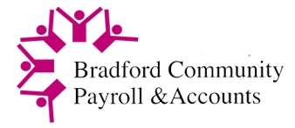

Bradford Community Payroll and Accounts

At BCPA we pride ourselves on serving the community of Bradford. We support businesses and charitable organisations by offering financial services that meet their needs. We continue to develop our financial support services, with over 30 years’ experience of delivering payroll, and accounts to Bradford and surrounding districts including Direct Payments for BMDC. During this exciting time, we want to grow our Board of Directors to ensure we are as diverse as the city of Bradford, with an aim to reflect this on the board.

We are looking for Directors to join the Board to ensure we are inclusive and vibrant. We currently have vacancies for Directors, Treasurer and Chair. Please find the job roles attached. Please be aware this is a voluntary unpaid position, but we do offer remuneration for expenses incurred. We currently have four full board meetings annually, but there is an expectation that Directors will also contribute to sub groups that may be formed from time to time to address business development, including other areas such as HR, finance and staff development.

If you are interested in applying for any of the roles, please submit an expression of interest, detailing which role you are applying for, it will be helpful if you could include the following.

- Current employment status
- Experience you have, linked to the role you are interested in (Attached JD’s)
- Any skills you feel will benefit BCPA
- Why you would like to be a director

Please send your expression of interest to maya@bradfordcpa.co.uk.

